Low-Level Design (LLD) — Dashboard Module
Attribute | Value
Module | Dashboard (Dealer / Order Overview Home)
Menu path | OVERVIEW → Dashboard
Landing pages | dashboard.php, index.php (same body)
Application | Complaint / Dealer Portal
Stack (target) | Core PHP + MySQL (PDO)
Stack (current repo) | Core PHP + PostgreSQL via PDO ($obconn, $dpconn)
Document version | 1.0
Access | RBAC module slug dashboard / permission view

â”€â”€â”€â”€â”€â”€â”€â”€â”€â”€â”€â”€â”€â”€â”€â”€â”€â”€â”€â”€â”€â”€â”€â”€â”€â”€â”€â”€â”€â”€â”€â”€

1. Module Overview

1.1 Purpose
The Dashboard is the post-login home page. It presents order-booking KPIs for a selected date period: pipeline counts (Created / Acknowledged / Pending / Dispatched), alerts, Chart.js summaries, a Recent Orders DataTable preview, and Quick Actions (New Order, Pending Orders, File Complaint). It does not show complaint or after-market KPI widgets.

1.2 Scope
In scope | Out of scope
Period filter + Refresh | Complaint / IB / Service Log / Spare Parts KPIs
Pipeline + stat cards + alerts | Full Recent Orders / Pending Orders CRUD pages
Monthly bar + status doughnut charts | Select2 on this page
Recent Orders preview (10 rows) + line modal | Dedicated api/*dashboard* JSON KPI API
Quick Actions (permission-gated links) | Outstanding Balance card (UI hidden placeholder)

1.3 High-level architecture
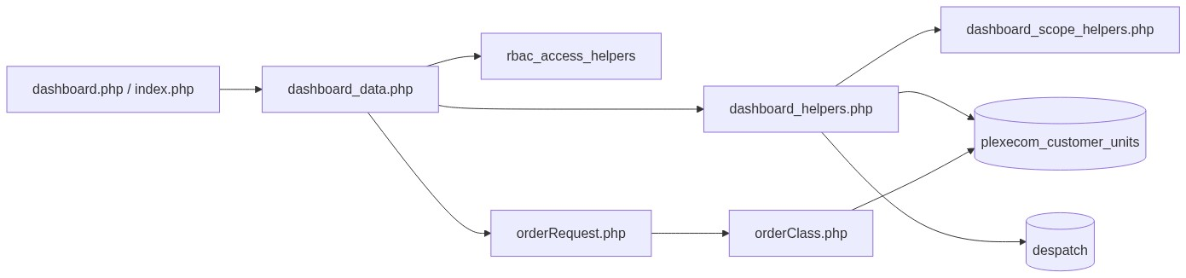
Figure 1 — High-level architecture
â”€â”€â”€â”€â”€â”€â”€â”€â”€â”€â”€â”€â”€â”€â”€â”€â”€â”€â”€â”€â”€â”€â”€â”€â”€â”€â”€â”€â”€â”€â”€â”€

2. Functional Requirements
ID | Requirement | Priority
FR-01 | Authenticated user with dashboard/view can open Dashboard | Must
FR-02 | Filter KPIs by period (Today … Last Year); default This Month | Must
FR-03 | Show pipeline counts: Created, Acknowledged, Pending, Dispatched | Must
FR-04 | Show Total / Pending / Dispatched summary cards | Must
FR-05 | Alerts: pending > 10 days; dispatches delivered this week | Should
FR-06 | Monthly Orders bar chart (last 6 months) | Should
FR-07 | Status Distribution doughnut chart | Should
FR-08 | Recent Orders preview DataTable (10 rows) when permitted | Must
FR-09 | Line-items modal for a recent order | Should
FR-10 | Quick Actions: New Order, Pending Orders, File Complaint | Should
FR-11 | Scope data by role / customer / SC assignments | Must
FR-12 | index.php and dashboard.php share the same dashboard body | Must

â”€â”€â”€â”€â”€â”€â”€â”€â”€â”€â”€â”€â”€â”€â”€â”€â”€â”€â”€â”€â”€â”€â”€â”€â”€â”€â”€â”€â”€â”€â”€â”€

3. User Roles & Permissions

3.1 RBAC module slug
Resource | Module | Permission
dashboard.php, index.php | dashboard | view

Gate: rbac_user_can($conn, 'dashboard', 'view') inside dashboard_data.php. Denied → access_denied.php. Unauthenticated → login.php.
System Admin does not auto-bypass this module (dashboard is in rbac_modules_enforcing_role_permissions()); grants come from role_permissions.

3.2 Related module permissions (widgets / links)
UI capability | Module slug | Permission
New Order / Created | order-booking | create-order
Recent Orders table / Total | recent-orders | list
Acknowledged | order-acknowledgement | list
Pending Orders | pending-order | list
Dispatched | despatch-details | list
File Complaint | complaint-entry | view

Resolved via dashboard_order_module_permissions().

3.3 Data scoping (runtime)
Source | Behavior
Active pipeline / monthly chart | See-all if System Admin or Management; else filter cuno = $_SESSION['customer_number_vayu'] (empty customer → zeros)
dashboard_resolve_view_scope | all (System Admin / CCS Admin), assigned (Sales Coordinator), self (Management / Dealers / Engineers), none
Despatch “this week” alert | Uses view-scope helpers
Added By column | System Admin / Management / CCS Admin

Known inconsistency: Management is see-all in active pipeline queries but self in dashboard_resolve_view_scope. CCS Admin is all in scope helpers but not in pipeline see-all (customer-scoped unless session customer set).

3.4 UI gate note
Many per-widget if ($can…) checks in dashboard_data.php are commented out. Once order cards show, most KPI pieces render even if finer-grained module permissions are missing. Quick Action links still respect individual flags where active.
â”€â”€â”€â”€â”€â”€â”€â”€â”€â”€â”€â”€â”€â”€â”€â”€â”€â”€â”€â”€â”€â”€â”€â”€â”€â”€â”€â”€â”€â”€â”€â”€

4. Business Rules
ID | Rule
BR-01 | Default period = this_month; unknown ?period= falls back to this_month.
BR-02 | Pipeline source = distinct recent rows from plexecom_customer_units filtered by indent_date period.
BR-03 | Created / Total = row count for period.
BR-04 | Acknowledged = non-empty order_number (AO).
BR-05 | Pending = empty order_number.
BR-06 | Dispatched = acknowledged AOs present in despatch (cmp != 600, trimmed ordno match).
BR-07 | Pending > 10 days = AO-empty rows with indent_date older than 10 days.
BR-08 | “Dispatches delivered this week” uses period this_week on despatch invdate with view scope.
BR-09 | Monthly chart always covers last 6 months (not the period dropdown).
BR-10 | Recent Orders preview: start=0, length=10, search/paging/sort UI disabled.
BR-11 | Outstanding Balance card is hidden (d-none) with placeholder value.
BR-12 | Chart payloads embedded as JSON with JSON_HEX_* + htmlspecialchars for XSS hardening.
BR-13 | Helper exceptions swallowed → counts return 0 (silent failure).
BR-14 | No session flash success/error for KPIs; alerts are computed copy only.
BR-15 | Post-login / SSO / remember-me land on index.php (same dashboard body).

â”€â”€â”€â”€â”€â”€â”€â”€â”€â”€â”€â”€â”€â”€â”€â”€â”€â”€â”€â”€â”€â”€â”€â”€â”€â”€â”€â”€â”€â”€â”€â”€

5. Database Design

5.1 Logical ER (KPI sources)
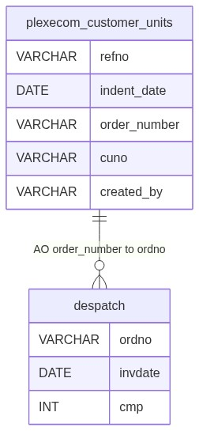
Figure 2 — Entity relationship diagram

5.2 Tables used
Table | Connection | Usage
plexecom_customer_units | $obconn | Pipeline KPIs, monthly chart, pending > 10 days, Recent Orders
despatch | $dpconn | Dispatched count; delivered-this-week alert
lr_details / dpst_master | $dpconn | Despatch alert joins (as implemented)
Lookup masters | $obconn | Recent Orders joins (delivery term, category, payterm, transporter)
user_master | $obconn | Optional Added By

5.3 Period SQL patterns (dashboard_period_date_sql)
Period key | Predicate idea
today | date = CURRENT_DATE
this_week | From week trunc through today
this_month | Same calendar month
last_3_months / last_6_months | Rolling intervals
this_year / last_year | Year trunc

5.4 Reference sources
Source | Usage
dashboard_period_options() | Period dropdown
dashboard_order_module_permissions() | Widget / link flags
dashboard_resolve_view_scope() | Despatch/alert scoping
$_SESSION['customer_number_vayu'] | Dealer customer filter

â”€â”€â”€â”€â”€â”€â”€â”€â”€â”€â”€â”€â”€â”€â”€â”€â”€â”€â”€â”€â”€â”€â”€â”€â”€â”€â”€â”€â”€â”€â”€â”€

6. API / Backend Design

6.1 Page endpoints
Endpoint | Method | Auth | Description
dashboard.php | GET ?period= | dashboard/view | Dashboard shell
index.php | GET ?period= | dashboard/view | Same body (login landing)

KPIs are server-rendered on page load via dashboard_fetch_stats() — no dedicated dashboard JSON KPI API.

6.2 AJAX endpoints (shared order module)
Endpoint | Action | Description
POST orderRequest.php | getRecentOrders | DataTables server-side for Recent Orders
POST orderRequest.php | getRecentOrderLine | HTML modal body for line items (orderNo)

Implemented in orderClass::getRecentOrders() / getRecentOrderLine().

6.3 Supporting lookup APIs
N/A for Dashboard KPIs (period options + stats in PHP).

6.4 Core PHP responsibilities
File | Role
dashboard.php / index.php | HTML shell + security headers
dashboard_data.php | Auth, RBAC, render KPIs/charts/table/actions
includes/dashboard_helpers.php | Period, stats, charts, alerts, permissions map
includes/dashboard_scope_helpers.php | Role view-scope SQL helpers
includes/rbac_access_helpers.php | Page/menu AuthZ
orderRequest.php + orderClass.php | Recent Orders AJAX

â”€â”€â”€â”€â”€â”€â”€â”€â”€â”€â”€â”€â”€â”€â”€â”€â”€â”€â”€â”€â”€â”€â”€â”€â”€â”€â”€â”€â”€â”€â”€â”€

7. Validation Rules

7.1 Server-side
Field / rule | Behavior
Session user | Empty usr_name → redirect login.php
Idle / session_version | Enforced before content
dashboard/view | Fail → access_denied.php
period query | Whitelist via dashboard_resolve_period; else this_month
Recent Orders AJAX | Relies on orderRequest / orderClass (no dedicated dashboard validator)

7.2 Client-side
â€¢ Period change: set period, clear month, navigate (full reload)
â€¢ Refresh: full page reload
â€¢ No validate.js form on Dashboard
â€¢ Chart data read from JSON script tags
â”€â”€â”€â”€â”€â”€â”€â”€â”€â”€â”€â”€â”€â”€â”€â”€â”€â”€â”€â”€â”€â”€â”€â”€â”€â”€â”€â”€â”€â”€â”€â”€

8. UI Screen Specifications

8.1 Main surface — dashboard_data.php
Element | Spec
Title | Dealer Dashboard
Period filter | Today, This Week, This Month, Last 3/6 Month, This Year, Last Year
Refresh | Reload current URL
Alerts | Orange pending > 10 days; green dispatches this week
Stat cards | Total Orders, Pending Orders, Dispatched This Month; Outstanding Balance hidden
Order Pipeline | Created / Acknowledged / Pending / Dispatched
Monthly Orders | Chart.js bar (Acknowledged + Pending)
Status Distribution | Chart.js doughnut
Recent Orders | DataTable preview + link to recent_orders.php
Quick Actions | New Order, Pending Orders, File Complaint
Modal | Order line items

8.2 Libraries
Library | Usage
Chart.js | Bar + doughnut
DataTables 1.13.8 | #orderTable serverSide
jQuery / Bootstrap 5 | AJAX modal + layout
Select2 | Loaded globally; not used on Dashboard

8.3 Modals
Recent order line-items modal filled by getRecentOrderLine.
â”€â”€â”€â”€â”€â”€â”€â”€â”€â”€â”€â”€â”€â”€â”€â”€â”€â”€â”€â”€â”€â”€â”€â”€â”€â”€â”€â”€â”€â”€â”€â”€

9. Database Flow

9.1 KPI load
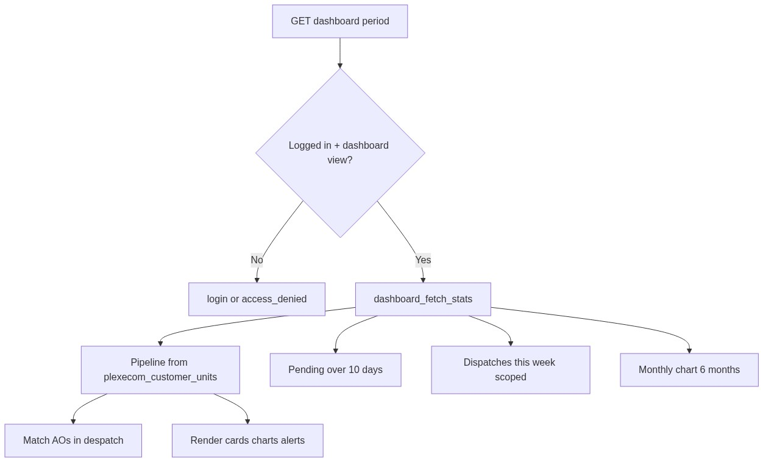
Figure 3 — KPI load database flow

9.2 Pipeline count pattern (conceptual)
-- Distinct recent units in period (simplified)
SELECT DISTINCT ON (refno) *
FROM plexecom_customer_units
WHERE /* period on indent_date */
AND /* optional cuno = :customer */
ORDER BY refno, /* latest */;
-- Created = count(*)
-- Acknowledged = order_number not empty
-- Pending = order_number empty
-- Dispatched = AO in despatch where cmp <> 600
â”€â”€â”€â”€â”€â”€â”€â”€â”€â”€â”€â”€â”€â”€â”€â”€â”€â”€â”€â”€â”€â”€â”€â”€â”€â”€â”€â”€â”€â”€â”€â”€

10. Sequence Diagram

10.1 Page load
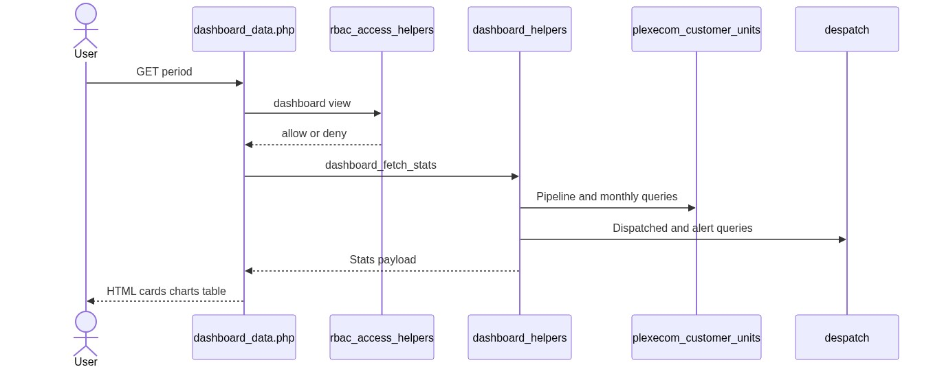
Figure 4 — Sequence: Page load

10.2 Recent Orders AJAX
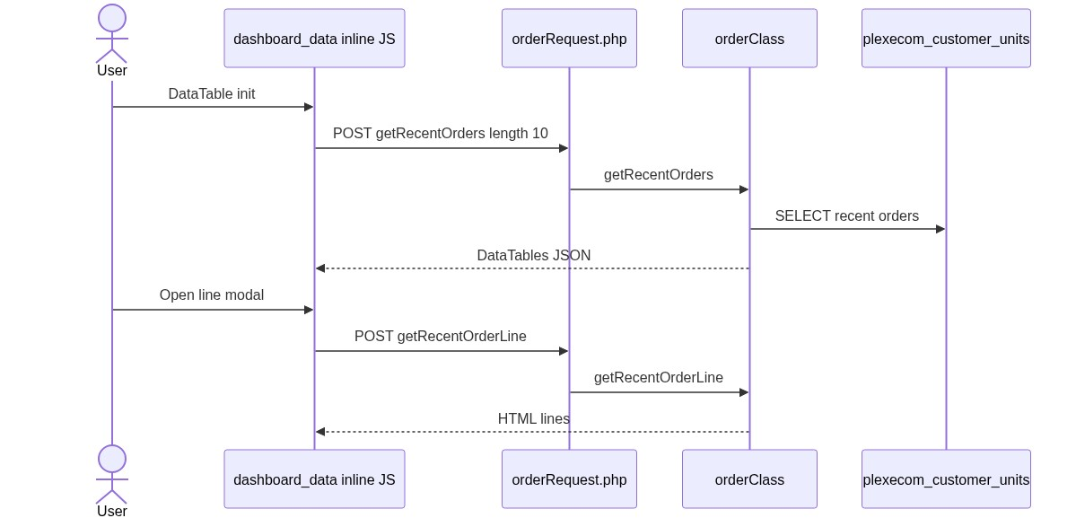
Figure 5 — Sequence: Recent Orders AJAX
â”€â”€â”€â”€â”€â”€â”€â”€â”€â”€â”€â”€â”€â”€â”€â”€â”€â”€â”€â”€â”€â”€â”€â”€â”€â”€â”€â”€â”€â”€â”€â”€

11. Activity Diagram
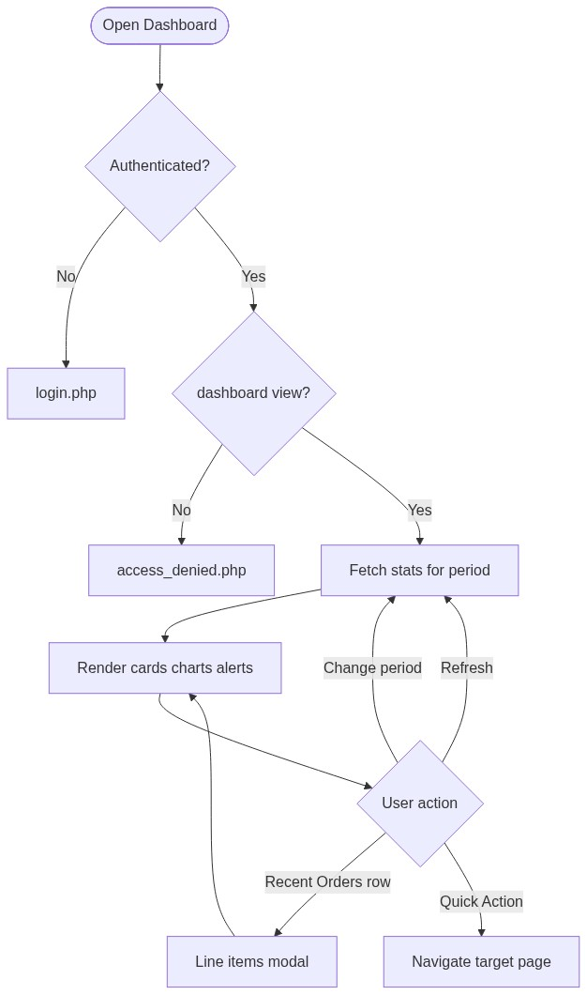
Figure 6 — Activity diagram
â”€â”€â”€â”€â”€â”€â”€â”€â”€â”€â”€â”€â”€â”€â”€â”€â”€â”€â”€â”€â”€â”€â”€â”€â”€â”€â”€â”€â”€â”€â”€â”€

12. Class / Module Diagram
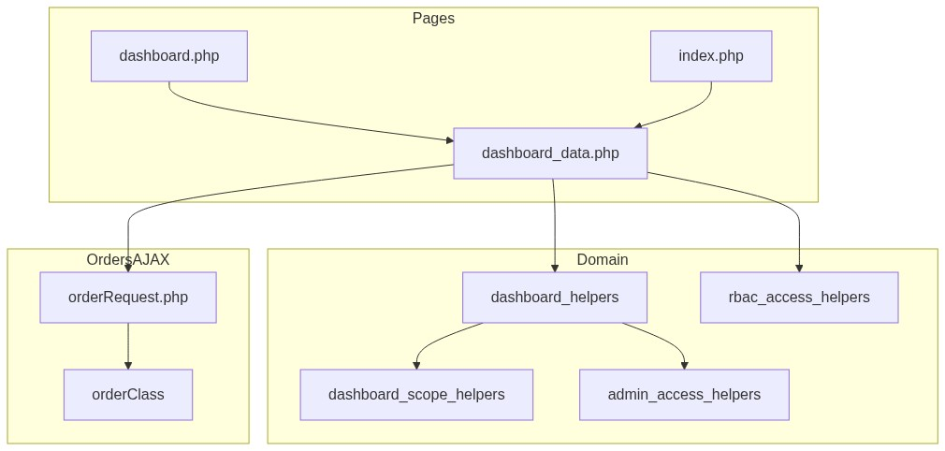
Figure 7 — Class / module diagram

12.1 Key functions
Function | Role
dashboard_order_module_permissions | Widget / link RBAC flags
dashboard_period_options / dashboard_resolve_period / dashboard_period_date_sql | Period whitelist + SQL
dashboard_fetch_stats | Orchestrate KPI payload
dashboard_fetch_recent_order_pipeline_stats | Created/ack/pending/dispatched
dashboard_count_recent_orders_with_invoice | Dispatched via despatch AO match
dashboard_fetch_pending_over_10_days_count | Alert count
dashboard_fetch_monthly_chart_data | 6-month series
dashboard_fetch_dispatched_count | Scoped despatch alert
dashboard_format_*_alert | Alert copy
dashboard_resolve_view_scope / dashboard_bind_* | Role SQL scope
orderClass::getRecentOrders / getRecentOrderLine | Table + modal

â”€â”€â”€â”€â”€â”€â”€â”€â”€â”€â”€â”€â”€â”€â”€â”€â”€â”€â”€â”€â”€â”€â”€â”€â”€â”€â”€â”€â”€â”€â”€â”€

13. Folder Structure
ComplaintManagement/
├── dashboard.php
├── index.php
├── dashboard_data.php
├── orderRequest.php
├── orderClass.php
├── access_denied.php
├── includes/
│ ├── dashboard_helpers.php
│ ├── dashboard_scope_helpers.php
│ ├── rbac_access_helpers.php
│ ├── admin_access_helpers.php
│ └── security_headers_helpers.php
├── css/
│ ├── stats.css
│ ├── pipeline.css
│ ├── chart.css
│ └── orderbook_style.css
├── header_css.php
├── script_js.php
├── sidebar.php
└── docs/
└── LLD_Dashboard_Module.md
â”€â”€â”€â”€â”€â”€â”€â”€â”€â”€â”€â”€â”€â”€â”€â”€â”€â”€â”€â”€â”€â”€â”€â”€â”€â”€â”€â”€â”€â”€â”€â”€

14. Error Handling
Layer | Pattern
Unauthenticated | Redirect login.php
No dashboard/view | access_denied.php
KPI query failure | Catch in helpers → return 0 / empty series
Recent Orders AJAX | Handled by orderRequest / orderClass JSON/HTML
rePushOrder() | Client alert('Coming Soon') only

14.1 User-visible messages
Message / UI | When
Pending > 10 days alert | Count > 0
Dispatches delivered this week | Count > 0
Access denied page | Missing dashboard/view
Coming Soon | Re-push action stub

No create/update flash messages on Dashboard itself.
â”€â”€â”€â”€â”€â”€â”€â”€â”€â”€â”€â”€â”€â”€â”€â”€â”€â”€â”€â”€â”€â”€â”€â”€â”€â”€â”€â”€â”€â”€â”€â”€

15. Security Considerations
Area | Control
Page AuthZ | RBAC dashboard/view + login + idle + session_version
XSS | Chart JSON escaped (JSON_HEX_* / htmlspecialchars)
SQL | Prepared / bound customer and scope params in helpers
KPI over-show | Many per-card permission ifs commented out
AJAX AuthZ gap | orderRequest.php lacks explicit recent-orders RBAC check
Tenant risk | orderClass may default customer_code to '10001' if session customer missing
Silent failures | Exceptions → zero counts (masks DB/config issues)
Headers | security_send_http_headers() on shell pages

â”€â”€â”€â”€â”€â”€â”€â”€â”€â”€â”€â”€â”€â”€â”€â”€â”€â”€â”€â”€â”€â”€â”€â”€â”€â”€â”€â”€â”€â”€â”€â”€

16. Audit Logs

16.1 Built-in field-level audit
Item | Behavior
Dashboard read audit table | Not implemented
KPI change history | N/A (read-only surface)
Underlying order/despatch audit | Owned by Order Booking / Despatch modules

Dashboard is a read aggregation UI; it does not write business tables.
â”€â”€â”€â”€â”€â”€â”€â”€â”€â”€â”€â”€â”€â”€â”€â”€â”€â”€â”€â”€â”€â”€â”€â”€â”€â”€â”€â”€â”€â”€â”€â”€

17. Test Cases

17.1 Functional
ID | Scenario | Expected
TC-01 | Guest opens dashboard.php | Redirect login
TC-02 | User without dashboard/view | access_denied.php
TC-03 | User with view opens page | KPIs render for default This Month
TC-04 | Change period to Last Year | Counts/charts reload for that period
TC-05 | Invalid ?period=foo | Falls back to This Month
TC-06 | Dealer with customer code | Pipeline scoped to cuno
TC-07 | Dealer without customer code | Pipeline zeros
TC-08 | System Admin / Management | See-all pipeline data
TC-09 | Pending AO empty > 10 days | Orange alert shows count
TC-10 | User with recent-orders/list | Recent Orders table loads 10 rows
TC-11 | Open line modal | Line HTML from getRecentOrderLine
TC-12 | Quick Action File Complaint without perm | Link hidden / not actionable
TC-13 | Login success | Lands on index.php dashboard
TC-14 | Outstanding Balance card | Not visible (d-none)

â”€â”€â”€â”€â”€â”€â”€â”€â”€â”€â”€â”€â”€â”€â”€â”€â”€â”€â”€â”€â”€â”€â”€â”€â”€â”€â”€â”€â”€â”€â”€â”€

18. Assumptions & Dependencies

18.1 Assumptions
1. dashboard/view is assigned to roles that should see the home page.
2. Order pipeline truth is plexecom_customer_units + despatch AO matching.
3. index.php and dashboard.php remain equivalent shells over dashboard_data.php.
4. Complaint and after-market analytics are intentionally out of scope for this page.
5. Document target stack Core PHP + MySQL; repo runs PostgreSQL date functions (DATE_TRUNC, INTERVAL).
6. Commented per-widget RBAC gates may be re-enabled later; document current behavior (mostly ungated once cards show).

18.2 Dependencies
Dependency | Purpose
RBAC / Assign Permissions | dashboard/view and related module grants
Order Booking data (plexecom_customer_units) | Pipeline + charts + Recent Orders
Despatch DB (despatch) | Dispatched KPIs / alerts
orderClass / orderRequest | Recent Orders AJAX
Chart.js + DataTables + jQuery | Visualization + preview table
Session customer_number_vayu / role helpers | Data scoping

â”€â”€â”€â”€â”€â”€â”€â”€â”€â”€â”€â”€â”€â”€â”€â”€â”€â”€â”€â”€â”€â”€â”€â”€â”€â”€â”€â”€â”€â”€â”€â”€

Appendix A — Period keys
Key | Label
today | Today
this_week | This Week
this_month | This Month (default)
last_3_months | Last 3 Month
last_6_months | Last 6 Month
this_year | This Year
last_year | Last Year

â”€â”€â”€â”€â”€â”€â”€â”€â”€â”€â”€â”€â”€â”€â”€â”€â”€â”€â”€â”€â”€â”€â”€â”€â”€â”€â”€â”€â”€â”€â”€â”€

Appendix B — Select2 control map
N/A. Period control is a native select / navigation pattern; Select2 is not used on Dashboard.
â”€â”€â”€â”€â”€â”€â”€â”€â”€â”€â”€â”€â”€â”€â”€â”€â”€â”€â”€â”€â”€â”€â”€â”€â”€â”€â”€â”€â”€â”€â”€â”€

Appendix C — Pipeline definition matrix
Metric | Definition
Created / Total | Count of period units rows
Acknowledged | order_number non-empty
Pending | order_number empty
Dispatched | AO found in despatch (cmp != 600)

â”€â”€â”€â”€â”€â”€â”€â”€â”€â”€â”€â”€â”€â”€â”€â”€â”€â”€â”€â”€â”€â”€â”€â”€â”€â”€â”€â”€â”€â”€â”€â”€

Appendix D — Post-login landing
Entry | Target
Password login | index.php
Remember-me | index.php
SSO (dashboard_path) | index.php
Sidebar Dashboard | dashboard.php

Both shells include dashboard_data.php.
â”€â”€â”€â”€â”€â”€â”€â”€â”€â”€â”€â”€â”€â”€â”€â”€â”€â”€â”€â”€â”€â”€â”€â”€â”€â”€â”€â”€â”€â”€â”€â”€
End of LLD — Dashboard Module

